HANDS-ON SESSION
List of Experiments:
Unit 1: Interactive Activity: Master Prompt Engineering
Real-world Scenario: Student Performance Evaluation
Worst Case Prompt (Beginner Level)
“Check student performance”
Sample Output:
Most students performed well.
Some students need improvement.
Provide additional support where needed.
Average Case Prompt (Intermediate Level)
Act as a faculty member.
Analyze the performance of 50 students based on assignment, and examination marks.
Identify high performers and low performers.
Provide suggestions for improvement.
Present the results in a table.
Best Case Prompt (Expert Level)
ROLE:
You are an experienced Academic Evaluator and Educational Data Analyst.
TASK:
Analyze student performance and identify strengths, weaknesses, and improvement opportunities.

CONTEXT:
The dataset contains:
- Student ID
- Student Name
- Attendance
- Subject-wise Marks
- Internal Assessment Marks
- Project Marks
- Final Examination Marks

FORMAT:
Generate:
1. Student Performance Summary
2. Top 10 Performers
3. At-Risk Students
4. Subject-wise Analysis
5. Attendance Impact Analysis
6. Recommendations

CONSTRAINT:
Use clear academic language and provide evidence-based recommendations.

Example 1:
ROLE:
You are a senior academic evaluator with 15 years of experience in Outcome-Based Education (OBE), assessment design, and student performance analysis.

TASK:
Evaluate the academic performance of students and identify high performers, average performers, and students requiring intervention.

CONTEXT:
The class contains 60 undergraduate students.
Assessment Components:
- Internal Assessment 1 (20 Marks)
- Internal Assessment 2 (20 Marks)
- Assignment (10 Marks)
- Mini Project (20 Marks)
- End Semester Examination (30 Marks)

Course Outcome Target:
70%
Students scoring:
- Above 80% = Excellent
- 60%–79% = Good
- 40%–59% = Average
- Below 40% = At Risk

FORMAT:
Present the output as a table containing:
| Student ID | Total Score | Performance Category | Strengths | Areas for Improvement | Suggested Intervention |

Also provide:
1. Class Average
2. Highest Score
3. Lowest Score
4. Top 5 Performers
5. Students Requiring Support

CONSTRAINT:
Provide constructive feedback.
Do not assign final grades automatically.
Suggest actionable interventions for improvement.
Use professional academic language.

Example 2 :
ROLE:
You are a senior academic evaluator with expertise in Outcome-Based Education (OBE), Learning Analytics, and Student Performance Assessment.

TASK:
Evaluate student performance and generate actionable insights for faculty intervention.

CONTEXT:
Course: Data Science
Class Strength: 60 Students
Assessment Components:
Quiz = 20 Marks
Assignment = 20 Marks
Project = 20 Marks
Mid Exam = 20 Marks
Final Exam = 20 Marks
Performance Classification:
Above 85% = Excellent
70%–84% = Good
50%–69% = Average
Below 50% = At Risk

FORMAT:
Generate:
1. Performance Dashboard
2. Student-wise Evaluation Table
| Student ID | Total Marks | Category | Strengths | Weaknesses | Recommended Action |
3. Course Statistics
- Class Average
- Highest Score
- Lowest Score
- Pass Percentage
4. Learning Gap Analysis
5. Top 5 Students
6. Bottom 5 Students
7. Faculty Intervention Plan

CONSTRAINT:
Use evidence-based recommendations.
Provide constructive feedback.
Avoid bias.
Do not assign final grades automatically.
Recommend specific teaching interventions for at-risk students.
Highlight topics requiring remedial teaching.

Task: 1
Example Prompt #1: “Research Proposal Development (your research idea)”

Hint:
"You are a PhD-level research methodology specialist with 15 years of experience
in behavioural economics. Help me create a comprehensive research proposal for a
study on decision-making biases in organizational settings.

Include:
1. Research title (compelling and specific)
2. Three research questions
3. Proposed methodology (qualitative/quantitative)
4. Expected contributions to the field
5. Timeline and resource requirements

Use formal academic language and suggest 3 seminal papers I should review.
Format as a structured proposal document with sections clearly labelled.

Task: 2
Example Prompt #2: Lesson Plan Creation

Best Practices for Prompting
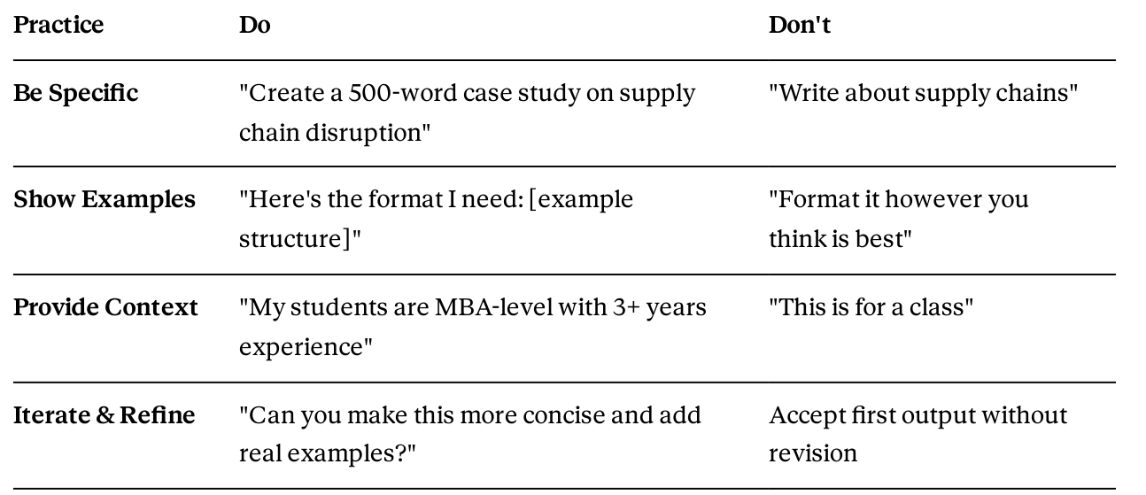

Tools Comparison
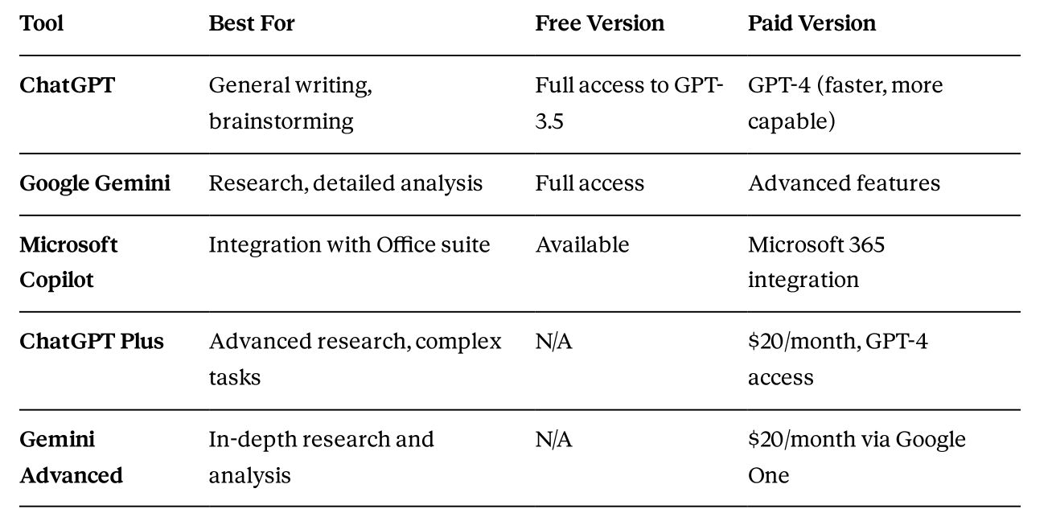

Final Conclusion:

Unit 2: AI for Research & Academic Content Development

Key Research Challenges Solved by AI

Challenge | Traditional Method | AI-Assisted Method
Literature review | 20-30 hours | 4-6 hours with AI tools
Gap identiﬁcation | Manual analysis of 50+ papers | AI cross-reference analysis
Citation formatting | Manual entry and checking | AI-powered citation generators
Proposal writing | 10-15 hours | 3-4 hours with AI drafting
Content creation | Complete from scratch | AI-augmented with your expertise

